**HUMAN FOLLOWING ROBOT**

*A Report submitted in partial fulfillment of the requirements to complete Term Work of Project Based Learning (PBL) in the department of*

**ELECTRONICS AND TELECOMMUNICATION ENGINEERING**

*As prescribed by*

**SAVATRIBAI PHULE PUNE UNIVERSITY**

*By*

**BHAUSAHEB PANJABRAO PACHPATIL 72294357B**

**ABHISHEK SUNIL MORVE 72294319K**

**GOPAL NARAYN MORE 72294314J**

**PRASAD HANUMANT NANAVARE 72294332G**

**PRADUMAN GAJANAN MOHOLE 72294311D**

*Under the Guidance of*

**PROF. A. S. DEOKATE**



**SMT.KASHIBAI NAVALE COLLEGE OF ENGINEERING**

**ELECTRONICS & TELECOMMUNICATION DEPARTMENT**

*44/1,Vadgaon(BK),Off sinhgad Road,Pune-411041.*



**SMT.KASHIBAI NAVALE COLLEGE OF ENGINEERING, PUNE-411041**

*Sr.no.44/1,vadgaon(BK), off sinhgad Road,Pune-411041.*

**Department of Electronics and Telecommunication Engineering**

***Certificate***

This is to certify that, following students,

ROLL NO

1.BHAUSAHEB PANJABRAO PACHPATIL E2343

2.ABHISHEKH SUNIL MORVE E2327

3.GOPAL NARAYAN MORE E2325

4.PRASAD HUNAMANT NANAVARE E2333

5.PRADUMAN GANAJAN MOHOLE E2324

has completed all the Term Work in the subject **Project Based Learning (PBL)** satisfactorily in the department of E&TC Engineering as prescribed by Savitribai Phule Pune University, in the academic year 2021-2022 SEM II

**Prof. A. S. Deokate** **Prof. S. K. Patil** **Dr. S. K. Jagtap**

Faculty In-Charge Co-ordinator HOD E&TC

Date:__/__/____

**TABLE OF CONTENT*: -***

1. ABSTRACT
2. INTRODUCTION
3. LIST OF COMPONENTS
4. BLOCK DIAGRAM
5. SYSTEM DESIGN
6. WORK CARRIED OUT
7. ADVANTAGES AND DISADVANTAGES
8. APPLICATIONS
9. RESULT
10. FUTURE WORK
11. CONCLUSION

REFERENCES

**ABSTRACT**

For a robot that performs autonomously, the communication between the person and the robot is the most important factor. A significant awareness has been observed regarding the usage of such a technology. This research has a trivial involvement in the development of such robots. A robot that functions fully autonomously should not only complete the jobs that are desired of them but also somehow establish a connection between themselves and the person operating them. A lot of research has been done of these kinds of robot and a lot of work still needs to be done. In order for a robot to communicate and interact with the person, it should also be capable of following that particular person. Keeping this in mind, there should be a capacity in the robot to get information from the surroundings while persuing the required object.

The primary goal of our work was to design and fabricate a robot that not only tracks the target but also moves towards it while doing the tracking. In order to make things simpler, a unique handmade tag was placed on the person that the robot needs to follow. The main hindrance in this kind of work is that the detection of the target is a sensitive thing to carry out. The object has to be unique for the robot to recognize it and carry out the objective.

The simple tag removes this problem of uniqueness and makes the task fairly easy. A small camera records the video and the processor processes it to extract the desired information from it. Protecting the robot from collision with the object is another problem that needs to be tackled so in order to do this, a sensor is used. All the processing is carried out by the microprocessor while the control of the motors is carried out by the controller.

Keywords — Human following, human tracking, visual imaging, human robot interaction, laser range scanners, image tag, envelope detection, service robots, depth image mapping, thermal conductivity***.***

**INTRODUCTION**

Robotic technology has increased appreciably in past couple of years. Such innovations were only a dream for some people a couple of years back. But in this rapid moving world, now there is a need of robot such as “A Human Following Robot” that can interact and co-exist with them.

To perform this task accurately, robot needs a mechanism that enables it to visualize the person and act accordingly The robot must be intelligent enough to follow a person in the crowded areas, vivid environment and in indoors and outdoors places

The image processing carried out to get the information about the surroundings visually is a very important thing. The following points should be carefully noted while doing the processing.

* The luminosity conditions should be very stable and should not fluctuate.
* The ranges should be set properly for the desired environment on which to perform the tracking.
* The target should not be very far from the visual sensor as the distance matters a lot.
* We should avoid the use of such colors around the robot that matches with that of the target. Otherwise the robot would get confused.

Typically human following robots are equipped with several different diverse combination of sensors i.e. light detection and ranging sensor, radio frequency identification module (RFID), laser ranger finder (LFR), infrared (IR) sensing modules, thermal imaging sensors, camera, wireless transmitter/receiver etc. for recognition and locating the target. All the sensors and modules work in unison to detect and follow the target.

The capability of a robot to track and follow a moving object can be used for several purposes.

* To help humans.
* To create ease for people.
* Can be used for defence purpose.

In this paper, we presented a method of a human following robot based on tag identification and detection by using a camera. Intelligent tracking of specified target is carried out by the use of different sensors and modules i.e. ultrasonic sensor, magnetometer, infrared sensors and camera. An intelligent decision is being made by the robot control unit based on the information obtained from the above sensors and modules, hence finding and tracking the particular object by avoiding the obstacles and without collision with the target.

**LIST OF COMPONENTS**

* WHEELS
* GEAR MOTOR
* ARDUION UNO
* INFRARED SENSORS
* ULTRASONIC SENSOR
* MOTOR DRIVER SHIELD
* SERVO MOTOR
* 18650 BATTERY HOLDER
* MALE AND FEMALE JUMPING WIRES
* DC POWER SWITCH

**BLOCK DIAGRAM**

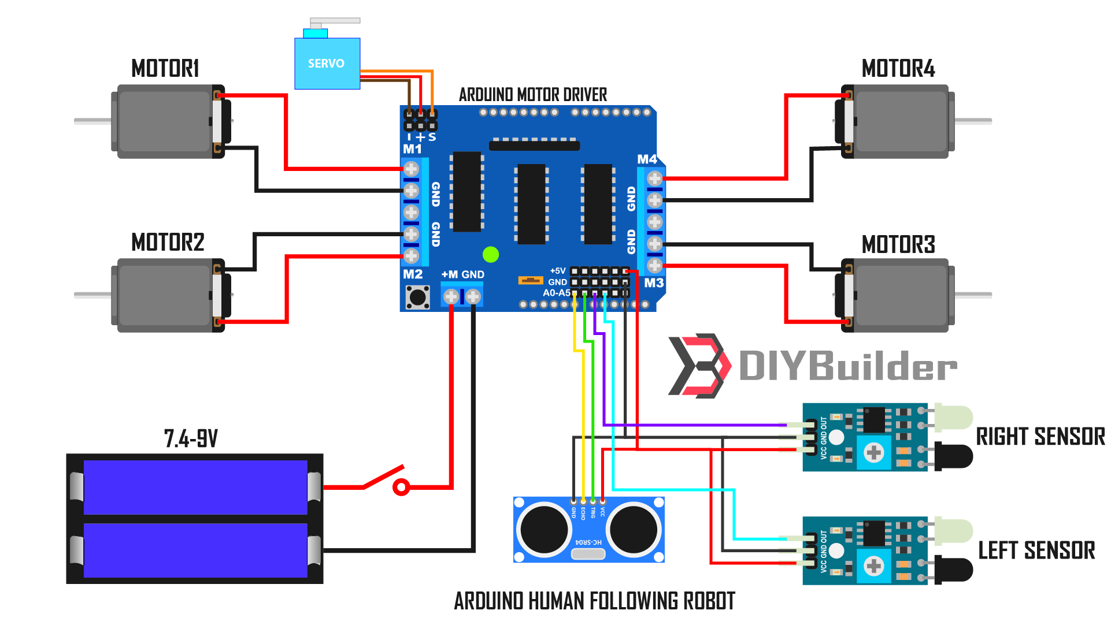

**SYSTEM DESIGN**

The system design consists of separate processing and control unit. The processing unit only makes use of a camera and is linked with the control unit to serially transmit the visual information after bulk processing. The control unit is serially linked with the processor and it makes use of several sensors and modules i.e. ultrasonic sensor, magnetometer and infrared sensors.

The above sensors and camera works in unison with each other and helps the robot in its operation and to navigate its path by avoiding the obstacles and maintaining a specific distance from the object. The decision is made on the basis of information obtained from all above sensors.

The generalized system design incorporating different sensors and modules is show below.



Looking at the working of the above system, the first phase is the detection of a tag by means of a camera and carrying out the substantial processing in the processing unit. The processor that we have used is Raspberry Pi single board computer. After the detection of tag next phase is to establish a serial communication between the processor and control unit. We have used Arduino as a control unit. In this phase center point coordinates of tag are serially transmitted to Arduino for further processing.

Next phase is to interface modules and necessary sensors with the control unit. For this purpose, we used ultrasonic sensor, magnetometer and IR sensors for the proper functioning of robot.

We used ultrasonic sensor for obstacle avoidance and to maintain a specific distance for the object. The ultrasonic sensor works accurately works accurately with in a range of 4 meters. Ultrasonic sensors operate by calculating the times differences.

This ultrasonic sensor is placed at the top of robot along with the camera module to maintain accuracy in measuring distance between the robot and target object.

The flow chart to maintain specific distance from target is shown below.



After ultrasonic sensor we interfaced the magnetometer to get the orientation of robot in x-y-z coordinates. This module determines the orientation of robot and tells heading direction of robot. This heading direction is used to determine the tilt of robot from its original position. On the basis of information obtained from this module, the control unit determines that how much direction change is required to be back on track again by after avoiding the obstacle.

After interfacing of above sensors, the next most important part of this system design is to interface the encoders to wheel calculate the distance travelled by the robot to eliminate any further error in the robotic movement due to displacement. For this purpose we attached two slot sensors on top of the encoder‟s right beside the wheels. The slot sensor has IR transmitter and a photodiode mounted on it and facing each other. The light emitted by the IR LED is blocked because of alternating slots of the encoder disc. This causes the logic level of the photo diode to change and is detected by the controller



The distance is obtained by the number of counts recorded in memory of the controller and is used for distance calculations by using the following formula.

Final phase is consisted of fusing all the information obtained by the sensors and modules in the control unit. Hence, control unit makes an intelligent decision to change the direction of robot and to get back on its track again and to follow the target having tag on basis of information obtained for all sensors and modules i.e. serially received coordinates from processor, distance information from ultrasonic sensor, heading direction from magnetometer, and distance calculation from the IR sensor.

**WORK CARRIED OUT**

.

Different experiments were conducted and the performance of the human following robot was tested. Each experiment that was performed took about 10 to 15 minutes. On the basis of results obtained from these tests and experiments, we made the necessary changes in the processing and control algorithm.

First test was performed on the ultrasonic sensor. It was noted that sensor was working accurately with in a range of 4 meters. Then we performed the test to check that weather the robot maintains a specific distance with target object. Initially the we set the stopping of robot to 8 inches. It was observed that robot collided with the object as the distance between robot and target object approaches to 8 inches. This problem behind this was that the stopping distance was small enough and robot was not stopping quickly because of its load on board. So we increased the distance to 12 inches. Then we again verified the routine.

The next test was performed on the magnetometer module. This module gave us the heading direction of the robot with respect to some reference. But we observed that there was some offset error in that heading direction. On observation we found that this was due to the wrong placement of the magnetometer module. This module was interfering with the magnetic field of the electronic components due to which we were getting the offset error. So we changed its placement and set it up at bottom layer and in the centre of the robotic structure. Now we had the heading degree without any offset error.

Then the next experiment was to test the detection of tag. We observed that in certain lightning conditions the tag was not detecting properly. So we adjusted the hue, saturation and value of all the four colours as colour thresholding in HSV varies by the lighting conditions. So after changing the threshold value we observed that this time the processor was detecting the Tag properly.

**ADVANTAGES**

**AND**

**DISADVANTAGES**

* Increased mobility: Human-following robots can navigate through crowded environments more easily than traditional robots. They are equipped with advanced sensors, cameras, and algorithms that allow them to detect and avoid obstacles, ensuring smooth navigation in various settings.
* Hands-free assistance: By following a human, these robots can provide hands-free assistance and carry objects, relieving humans of the burden of carrying heavy loads. This can be particularly beneficial in environments like airports, hospitals, or warehouses where people often need to transport items.
* Improved safety: Human-following robots can be programmed to monitor and ensure the safety of individuals in different scenarios. For instance, in outdoor activities or hiking, a robot can follow a person and alert them of any potential dangers or hazards along the way.
* Personalized interaction: These robots can be designed to recognize and respond to specific individuals, making interactions more personalized. They can remember preferences, adapt to individual needs, and provide tailored assistance or information, creating a more engaging and user-friendly experience.
* Enhanced accessibility: Human-following robots can be particularly beneficial for people with mobility impairments or disabilities. By following an individual, these robots can provide assistance and support in navigating various environments,

Disadvantage

* Limited processing power: Arduino boards are microcontrollers with limited processing power compared to more powerful computer systems. This limitation can affect the robot's ability to handle complex algorithms for navigation, obstacle detection, or image processing required for accurate human tracking.
* Sensor limitations: Arduino-based robots may have limited sensor capabilities. The available sensors may have lower resolution, range, or accuracy compared to more advanced sensors used in higher-end robots. This can affect the robot's ability to accurately detect and track humans, especially in dynamic or challenging environments.
* Limited battery life: Arduino-based robots often operate on battery power, which can have limited capacity. Following a human for extended periods can consume significant energy, potentially resulting in shorter battery life and frequent recharging or replacement of batteries. This limitation can reduce the robot's operational time and overall effectiveness.
* Lack of robustness and durability: Arduino boards and related components may not be as robust or durable as those used in industrial-grade robots. This limitation can affect the robot's reliability, especially in rugged or demanding environments where the robot may experience vibrations, impacts, or exposure to harsh conditions.
* Programming complexity: Arduino programming requires knowledge of the Arduino programming language, which may have a learning curve for individuals without prior programming experience. Developing complex algorithms for human following, obstacle avoidance, and other advanced functionalities may be challenging for beginners or those without a strong programming background.
* Limited communication capabilities: Arduino boards typically have limited communication

**APPLICATION**

* Personal assistance: The robot can follow an individual, carrying their belongings or providing hands-free assistance. This can be particularly useful for individuals with mobility limitations or in scenarios where people need help with carrying objects.
* Guided tours: In museums, exhibitions, or other public spaces, the robot can follow visitors and provide them with information about exhibits or displays. It can offer a personalized and interactive experience by tailoring information based on the visitor's interests.
* Retail and shopping: The robot can follow customers in a retail environment, assisting them with finding products, offering recommendations, or providing information about promotions and discounts**.**
* Hospitality industry: In hotels or resorts, the robot can accompany guests to their rooms, carry their luggage, or provide basic information about the facilities and services available.
* Security and surveillance: The robot can follow security personnel or patrol designated areas, helping to monitor and detect suspicious activities or potential security breaches. It can act as an extra set of eyes and ears in a security system.
* Education and research: Human-following robots can be used in educational settings to engage students in interactive learning experiences. They can follow teachers, assist in classroom activities, or even participate in research experiments.
* Events and entertainment: In theme parks, exhibitions, or entertainment venues, the robot can follow performers or characters, enhancing the overall experience and interaction for visitors.
* Healthcare and elderly care: Human-following robots can assist healthcare providers or caregivers in hospitals or assisted living facilities. They can follow patients, carry medical supplies, or act as a communication platform between patients and healthcare professionals.
* Photography and filming: The robot can follow a subject or a photographer, capturing footage or images from different angles and perspectives. This can be particularly useful in sports events, documentaries, or film production.
* Experimental robotics and prototyping: Arduino-based human-following robots can be used as a starting point for learning robotics, experimenting with algorithms, and exploring the possibilities of human-robot interaction.

**FUTURE WORK**

There are many interesting applications of this research in different fields whether military or medical. A wireless communication functionality can be added in the robot to make it more versatile and control it from a large distance. This capability of a robot could also be used for military purposes. By mounting a real time video recorder on top of the camera, we can monitor the surroundings by just sitting in our rooms. We can also add some modifications in the algorithm and the structure as well to fit it for any other purpose. E-g a vehicle follower.

Similarly it can assist the public in shopping malls. So there it can act as a luggage carrier, hence no need to carry up the weights or to pull that. Using this algorithm the robot will automatically follow that person.

**CONCLUSION**

A successful implementation of a person follower robot is illustrated in this research. This robot does not only have the detection capability but also the tracking and following ability as well. The tracking is basically performed on the tag and the human is followed on the basis of that detection. It was also kept in mind that the „following‟ capability of the robot should be as efficient as possible. The tests were performed on the different conditions to pin point the mistakes in the algorithm and correct them. The different sensors that were integrated with the robot added an additional advantage.

**REFERENCE**

1. K. Morioka, J.-H. Lee, and H. Hashimoto, “Human-following mobile robot in a distributed intelligent sensor network,” *IEEE Trans. Ind. Electron.*, vol. 51, no. 1, pp. 229–237, Feb. 2004.
2. Y. Matsumoto and A. Zelinsky, “Real-time face tracking system for human-robot interaction,” in *1999 IEEE International Conference on Systems, Man, and Cybernetics, 1999. IEEE SMC ’99 Conference Proceedings*, 1999, vol. 2, pp. 830–835 vol.2.
3. T. Yoshimi, M. Nishiyama, T. Sonoura, H. Nakamoto, S. Tokura, H. Sato, F. Ozaki, N. Matsuhira, and H. Mizoguchi, “Development of a Person Following Robot with Vision Based Target Detection,” in *2006 IEEE/RSJ International Conference on Intelligent Robots and Systems*, 2006, pp. 5286–5291.
4. H. Takemura, N. Zentaro, and H. Mizoguchi, “Development of vision based person following module for mobile robots in/out door environment,” in *2009 IEEE International Conference on Robotics and Biomimetics (ROBIO)*, 2009, pp. 1675–1680.